**Macro Economic To Micro Technical**

---

Macro is not a daytrading perspective, its long term daily charts ICT uses this for a long term perspective on the market

ICT doesnt believe in banks, because why would a bank tell you what there intentions are. That doesnt make sense. Its like football team telling you what their plays are going to be for the super bowl.

ICT looks for a 3-6 months outlook (Long term), 1 thing he uses for that is interest rates. The bond market

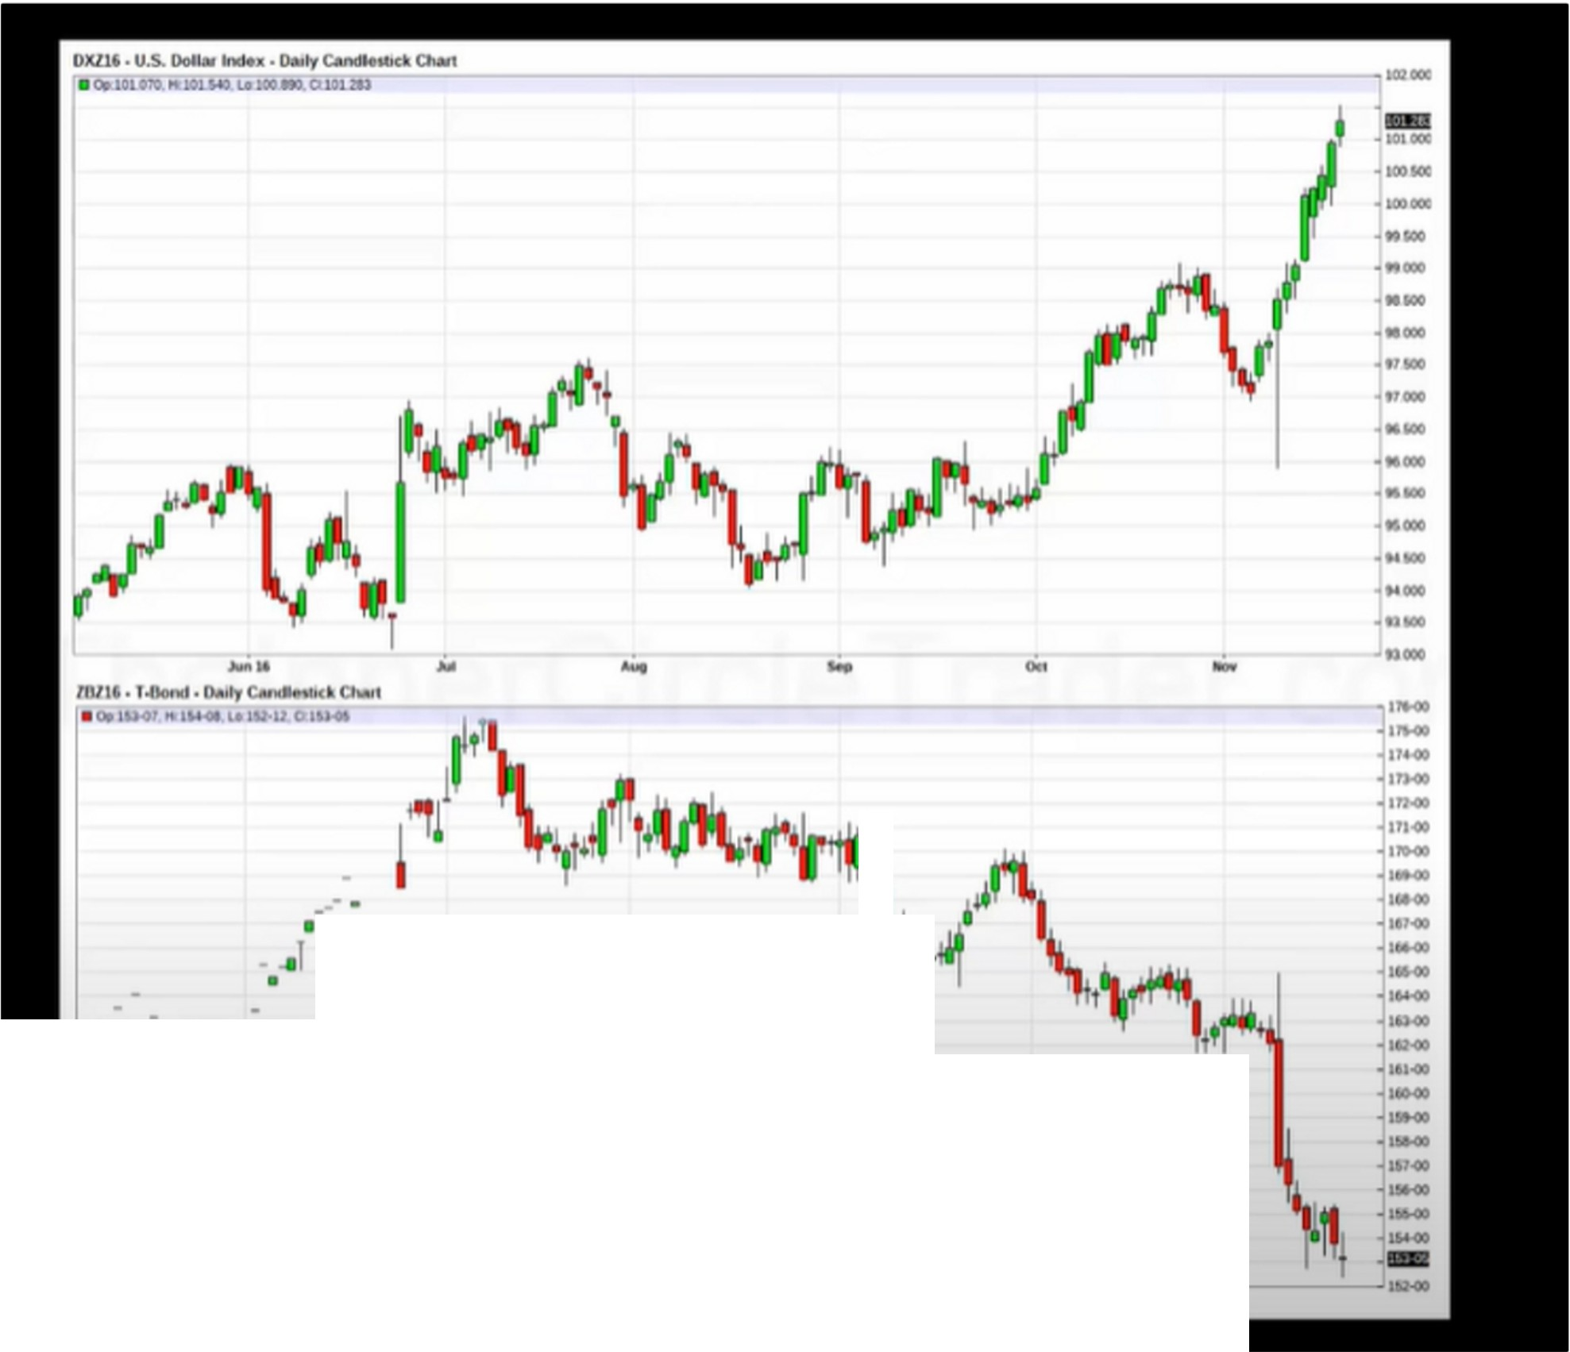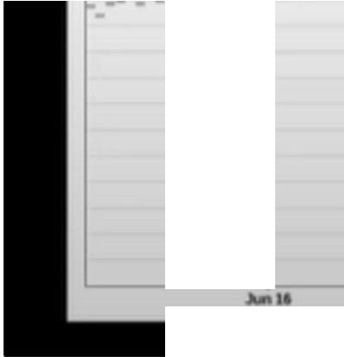

---

-.-·

I

'

-

-

Both december contracts in this case, use barchart

Every 3-4 months there is a quarterly shift, either a reversal or an extended period of consolidation and then a resume of the trend or a reversal

ICT doesnt use much fundamentals, he uses a visual interpertation of the data, the bond market and the 10 year notes will tell him that. And then he has a good indication of what the interest rates will do.

Interest rates higher - dollar goes higher Interest rates higher - bond market drops Bond market higher - interest rates dropping Bond market lower - interest rates higher

30 year treasury bond is for mortgage in america 10 year bond

SMT from lesson 5 will be applied here, between the bond market and the dollar Around every 3-4 months there will be this shift and so SMT will occur

This is aimed to give you a 3-4 month outlook on where the currency will be going

urts fOt't>I Opuons ETFs & funds News My 8'rchart Prtmium StMCts Sto(k.J futures F0<tic OptoOftl £Tfs & funds News M)' B,rch•rt Premium M<H

QUICttCHAIU! H) S·N)' 1-Mth ).Mth f,Mth l•YHr s-vur - j.,,,,,.....-.. j *,/'* 1-(Hy S-0., 11,!th J t, ..Mth 1-YNI 5.-,.., M,J,; [ ......,, "

[ntc,Symbol: ZkZ16

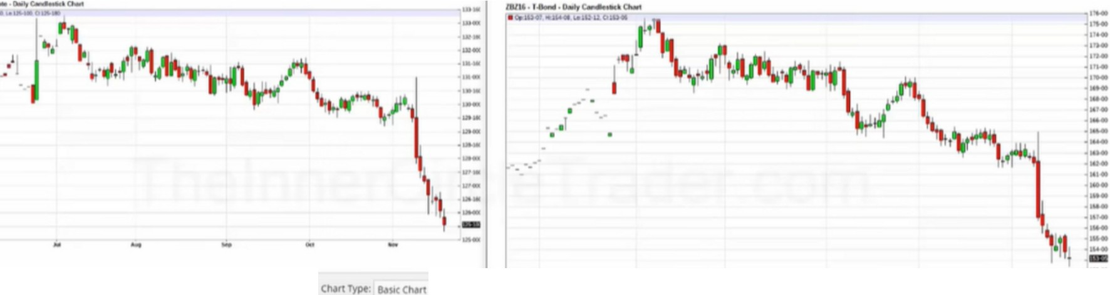

CNftSalt LMDf' .,, (nttrS)'mbol ZIZII

,erlod; [)a (Ol'IO,l(l ., 6 MMthS ., M,ns Of MM/Of)/'('(f't • MM,00/Y'tn

..

S.t1lng1:C t>d,s ., VOlumtotf .,, .; S,h(,,NPn(ff

* Llnffr sc,1t LOOl'•IMltc: SC.. • hl(t S(,IJt Ch SUit



**M·1 lfr'iF**

Study Add T h ,11 'ill)01

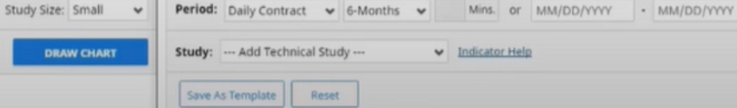

SMT between 10 year note and the 30 year T bond market, so right away we know we should see an rally for the dollar a the end of september

So if we see a rally in the dollar we can expect a rally in USO-... pairs and a drop in ... -USO pairs

Macro economics to then micro technical, take all this information and then in september start looking for USO pairs a reason to be long on the technical part

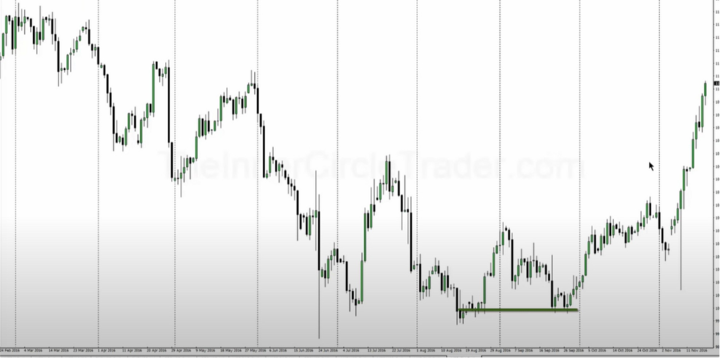

It builds an idea of where the market wants to go based on fundamentals without looking at the numbers

The interest markets control everything around the world, without it nothing moves

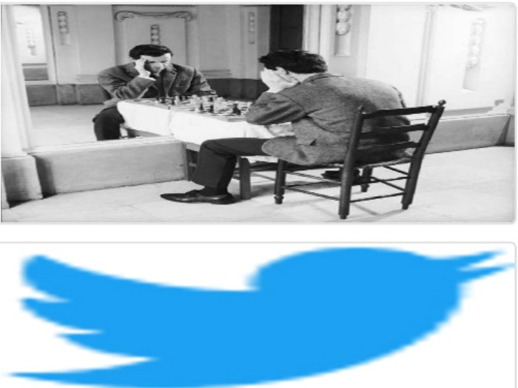Arjo I Twitter, lnstagram I Linktree

Linktree. Make your link do more. https://t.co/HhmmTN1fUI

JavaScript is not available.

'I# https://twitter.com/arjoio